|  |  |
| --- | --- |
| C:\awsTraining\screen-shot-2020-06-18-at-3.23.45-pm-1.png  UDAPEOPLE | pROJECT evidences    Sudhachandiran Natarajan |

# The first build fails in Circle-CI

We have to comment and fix few errors to make the circle pipeline working

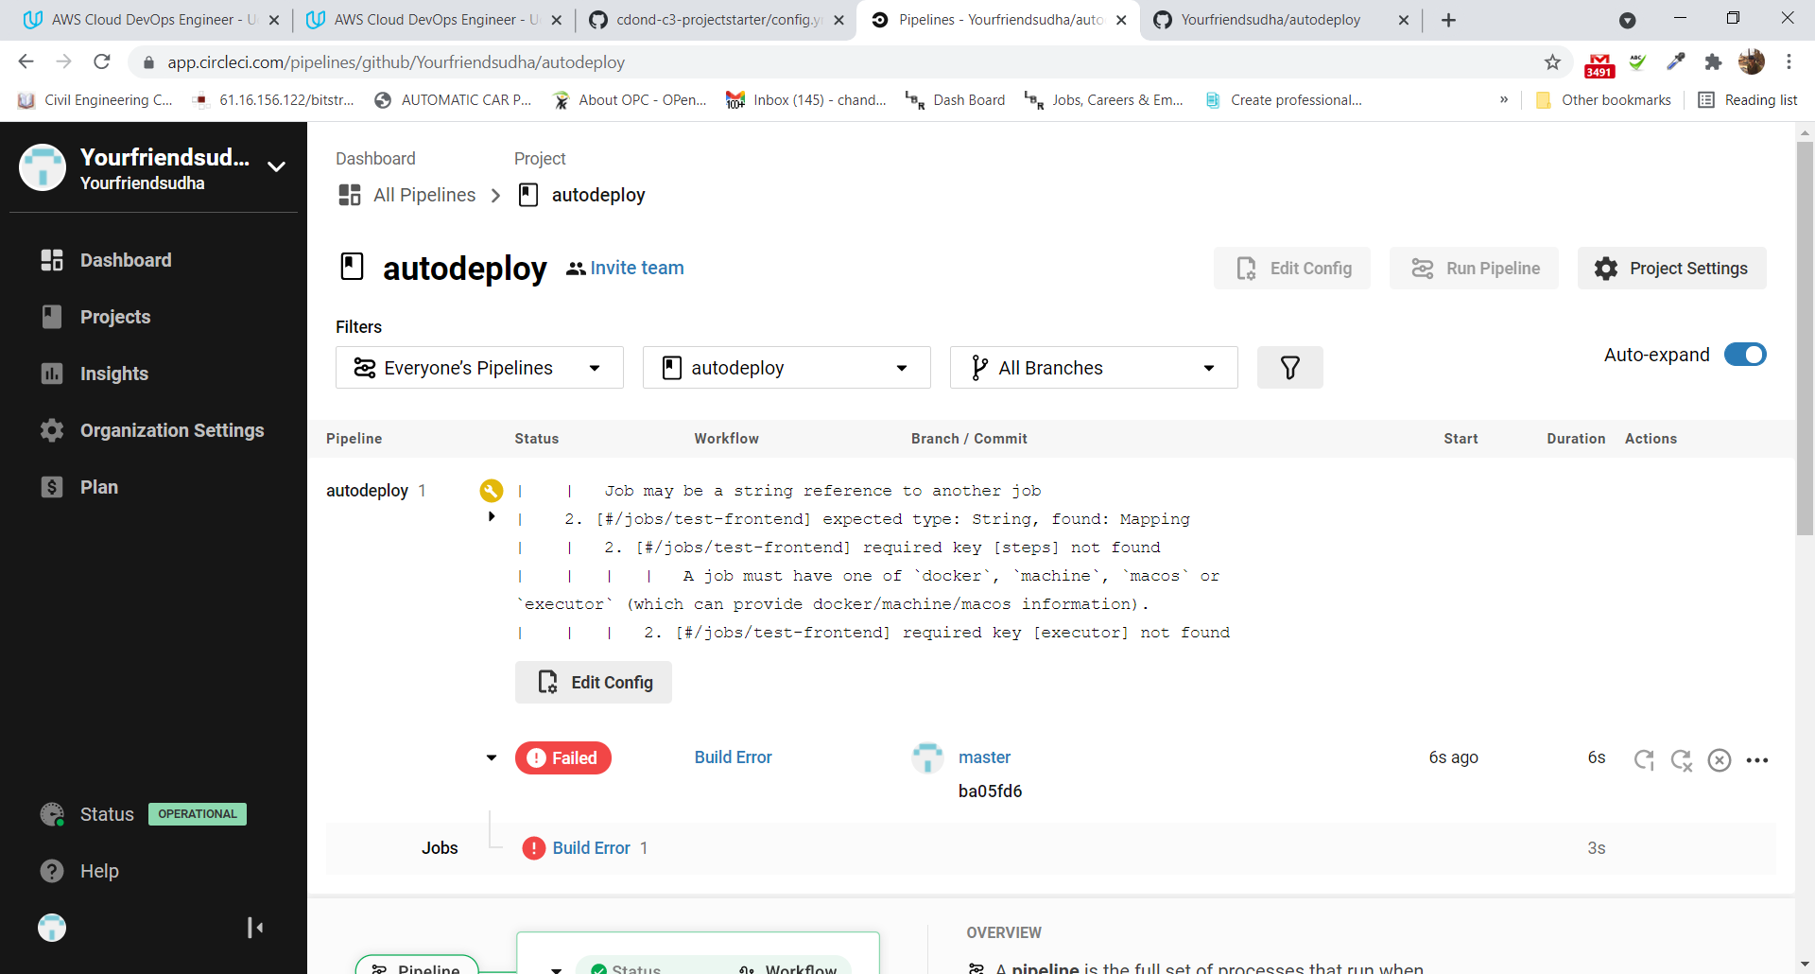

# SCREENSHOT-01 – Compile error in Build

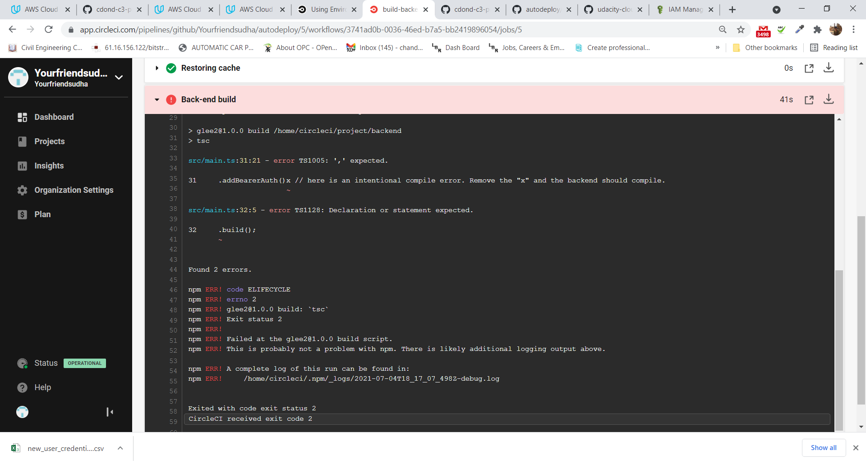

# SCREENSHOT-02 – Test Failures

## Backend test failure

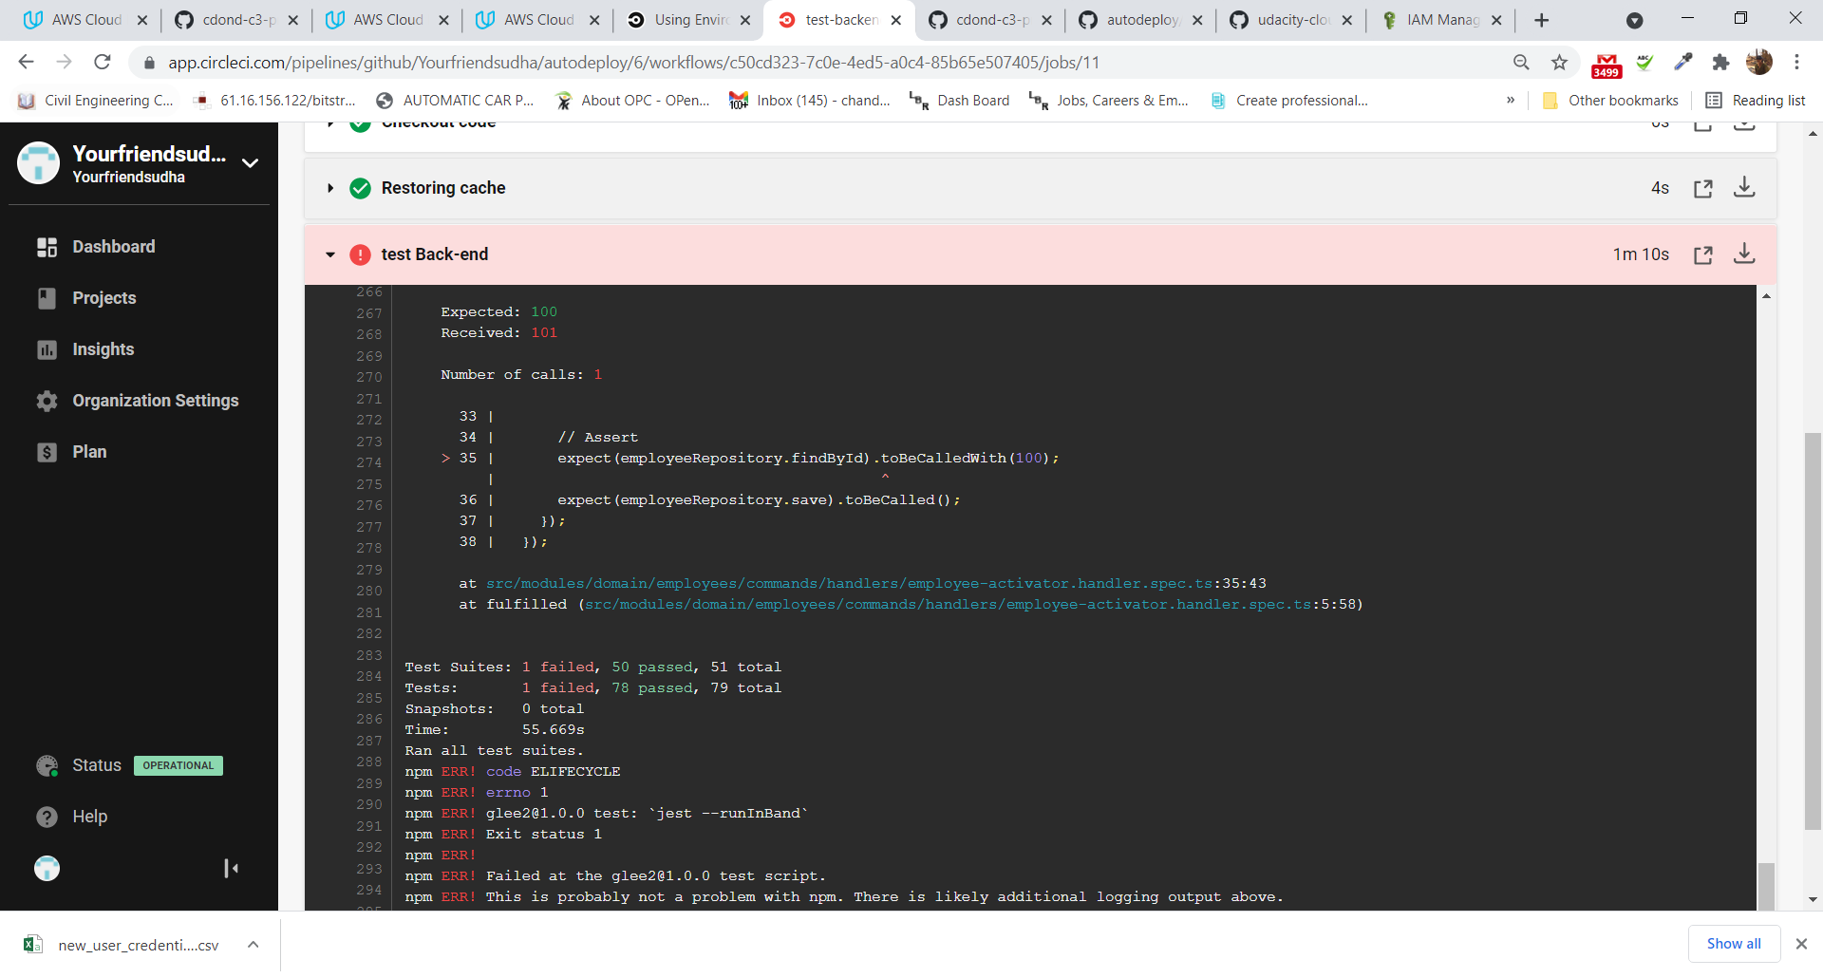

## Front test failure

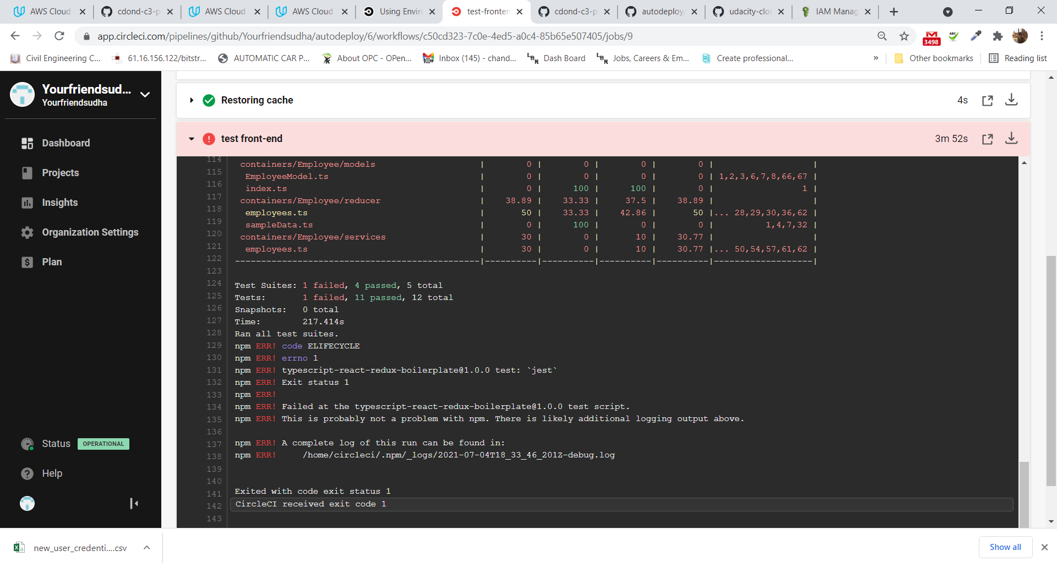

# SCREENSHOT-03 – Scan backend

Failure as it had vulnerabilities

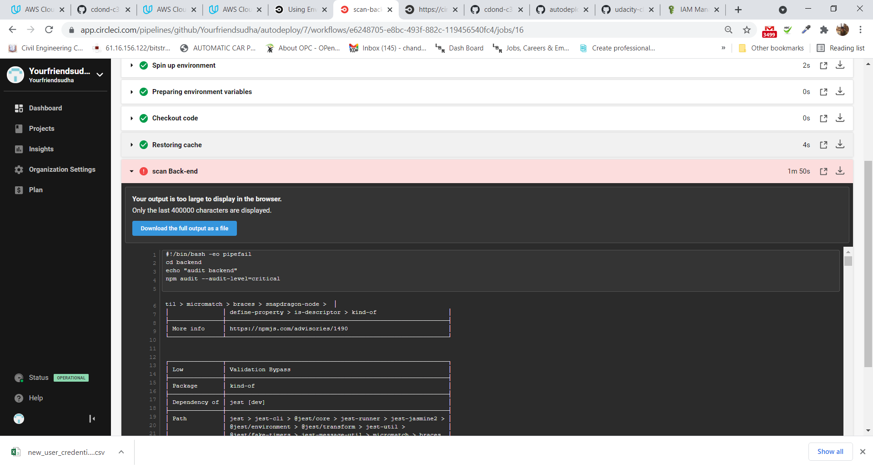

# SCREENSHOT-04 – Alerts in Slack

Created a new slack – **awsprojects** and integrated using orb in circleci

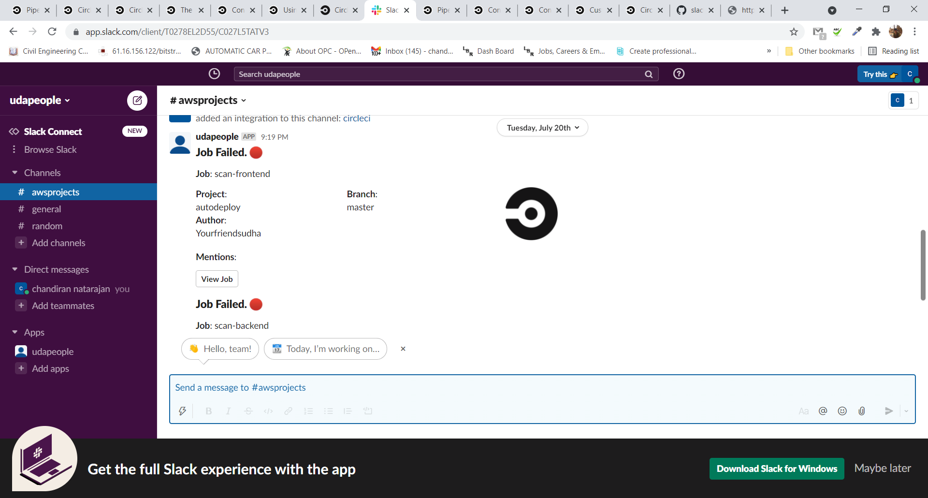

# SCREENSHOT-05 – Cloudformation Stack error

Failed to create cfn stack

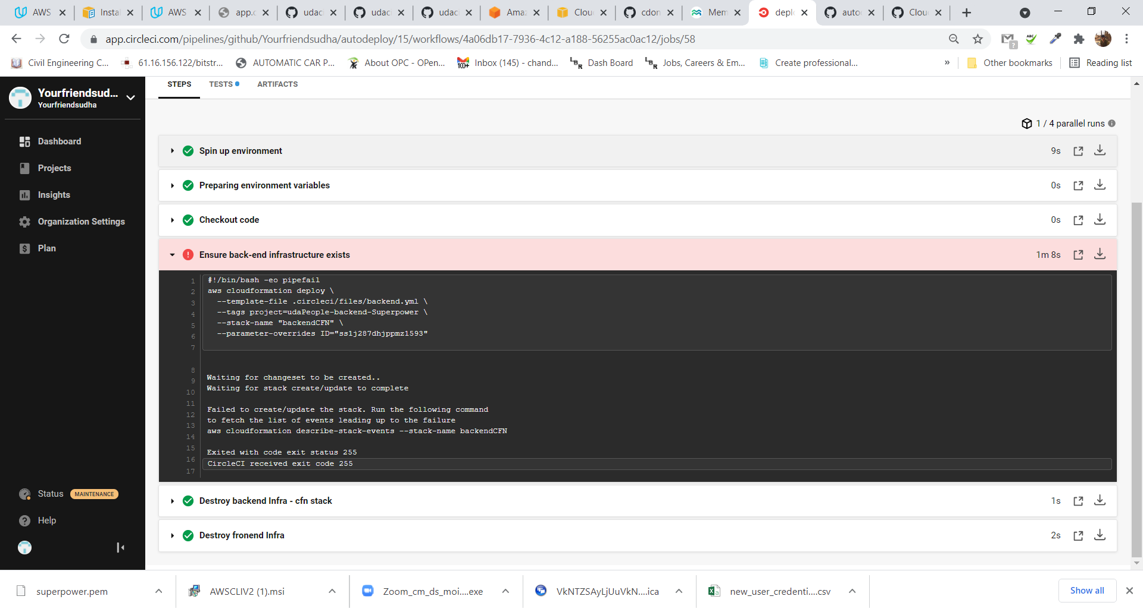

# SCREENSHOT-06 – Frontend smoke test failure

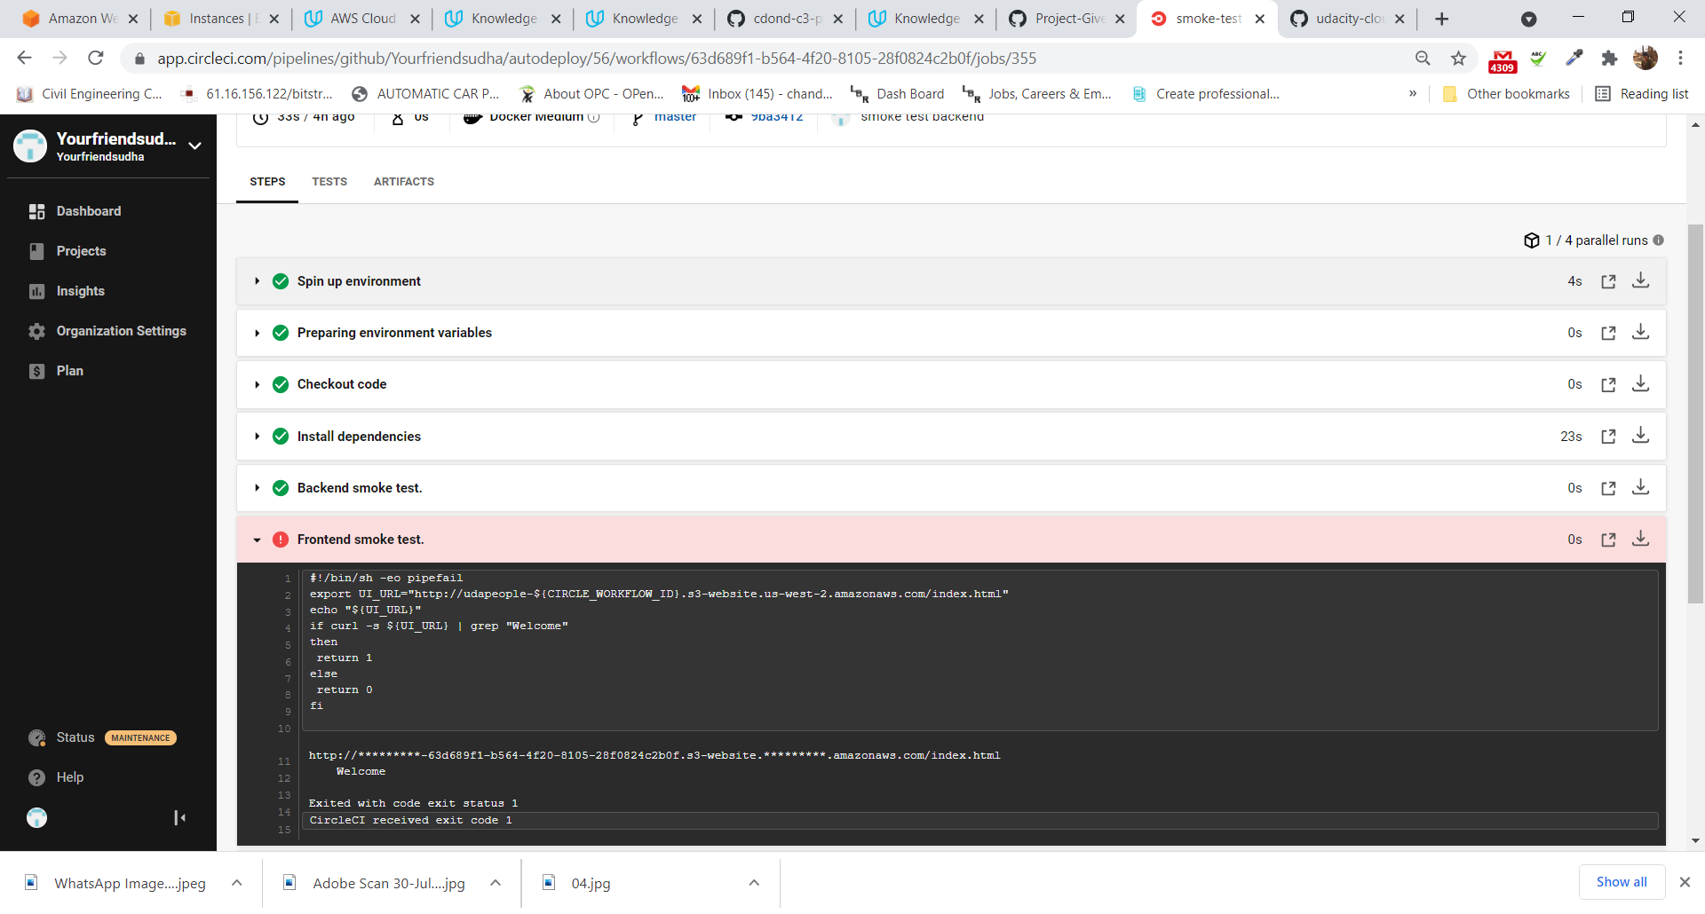

# SCREENSHOT-07 – Rollback success

Whenever there is a failure in pipeline, the resources are automatically deleted and DB migrations are reverted.

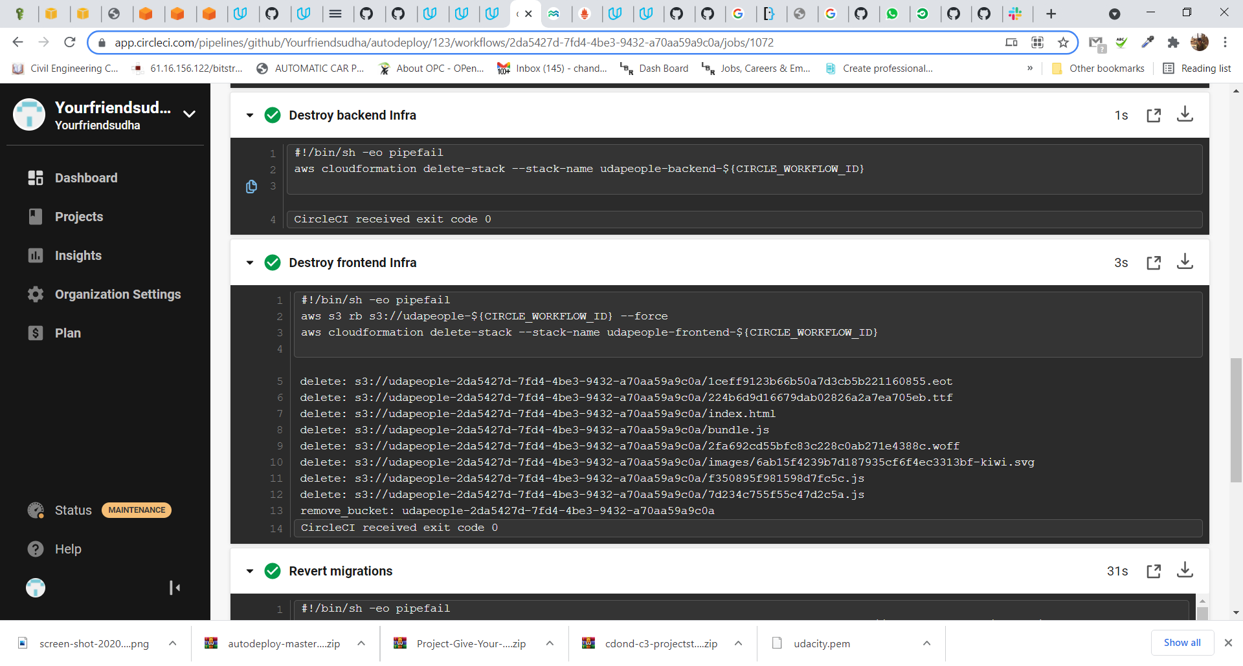

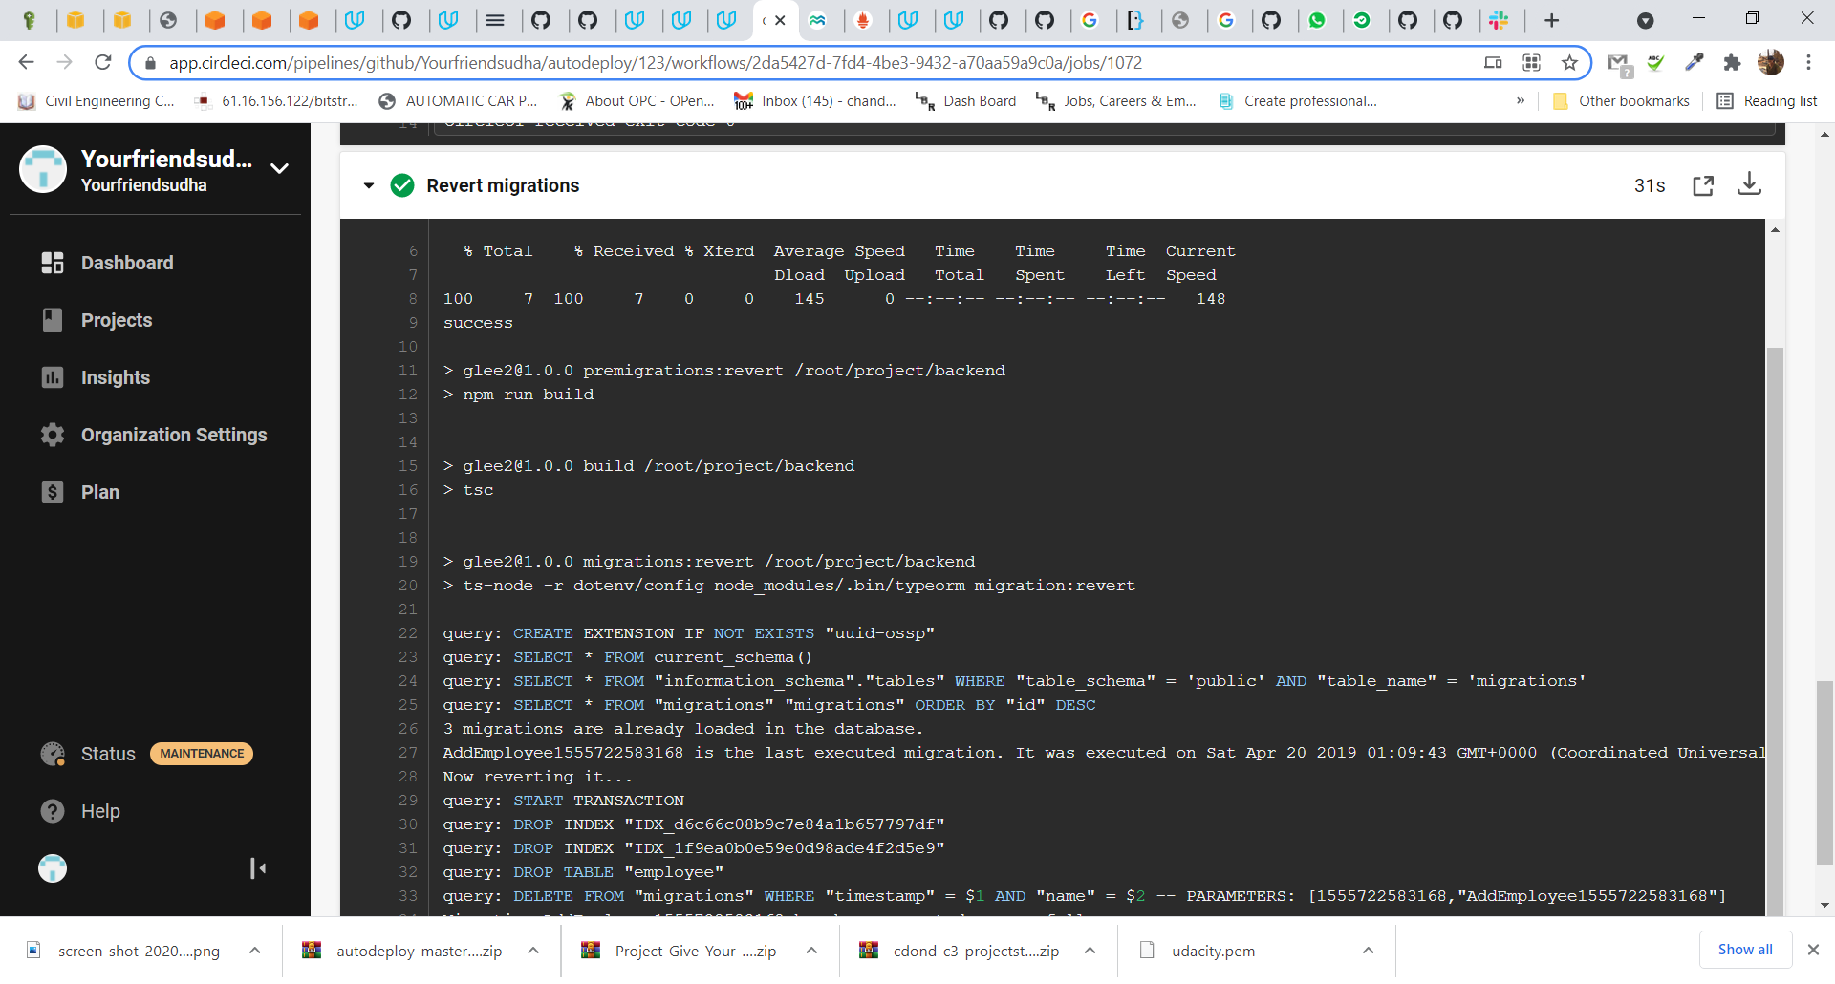

# SCREENSHOT-08 – Cloudfront update

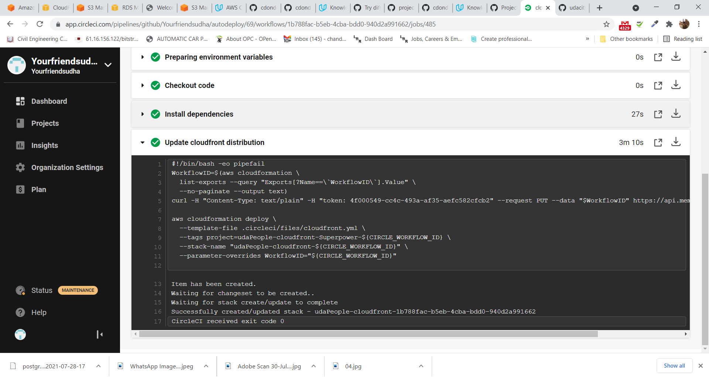

# SCREENSHOT-09 – Cleanup

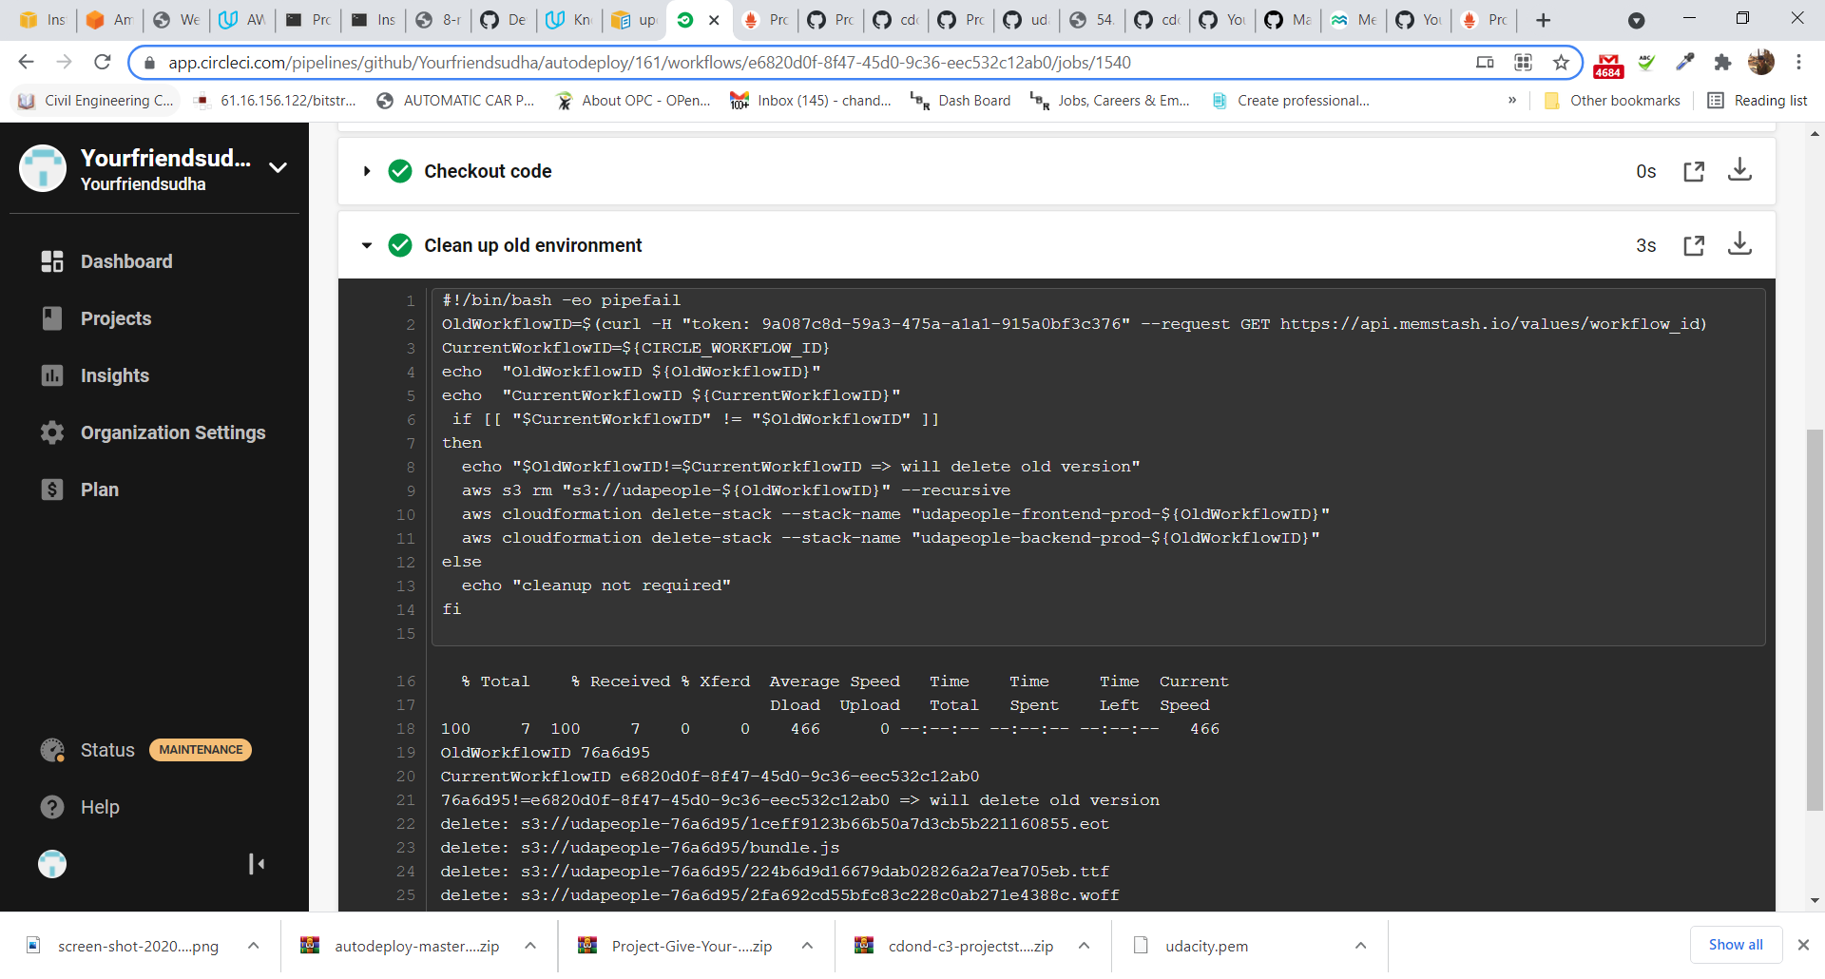

# SCREENSHOT-10 – Filter Master branch

If code is committed to any branch other than master, the pipeline will not progress to deploy phase.

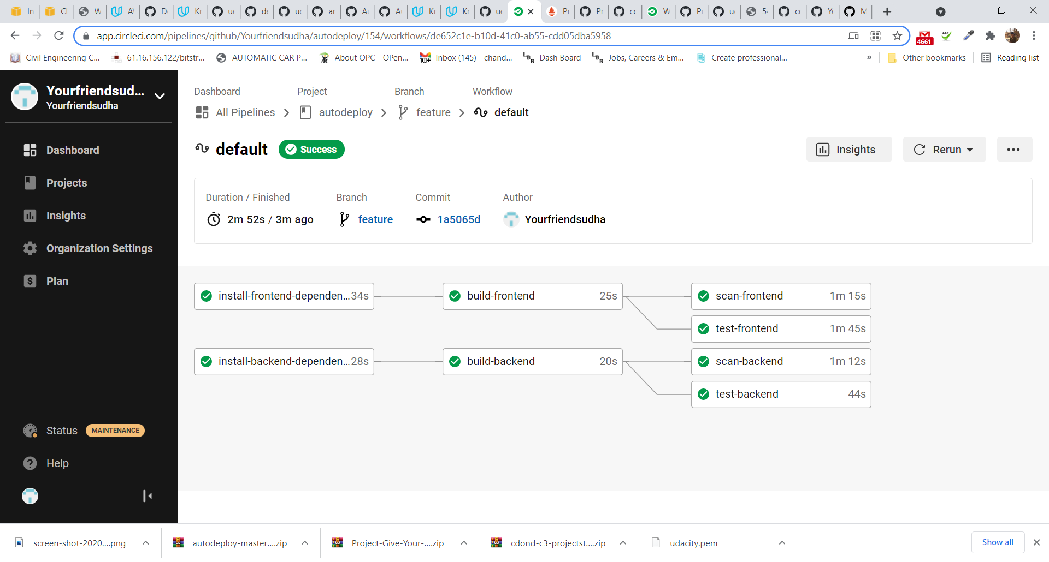

# SCREENSHOT-11 – Prometheus graph

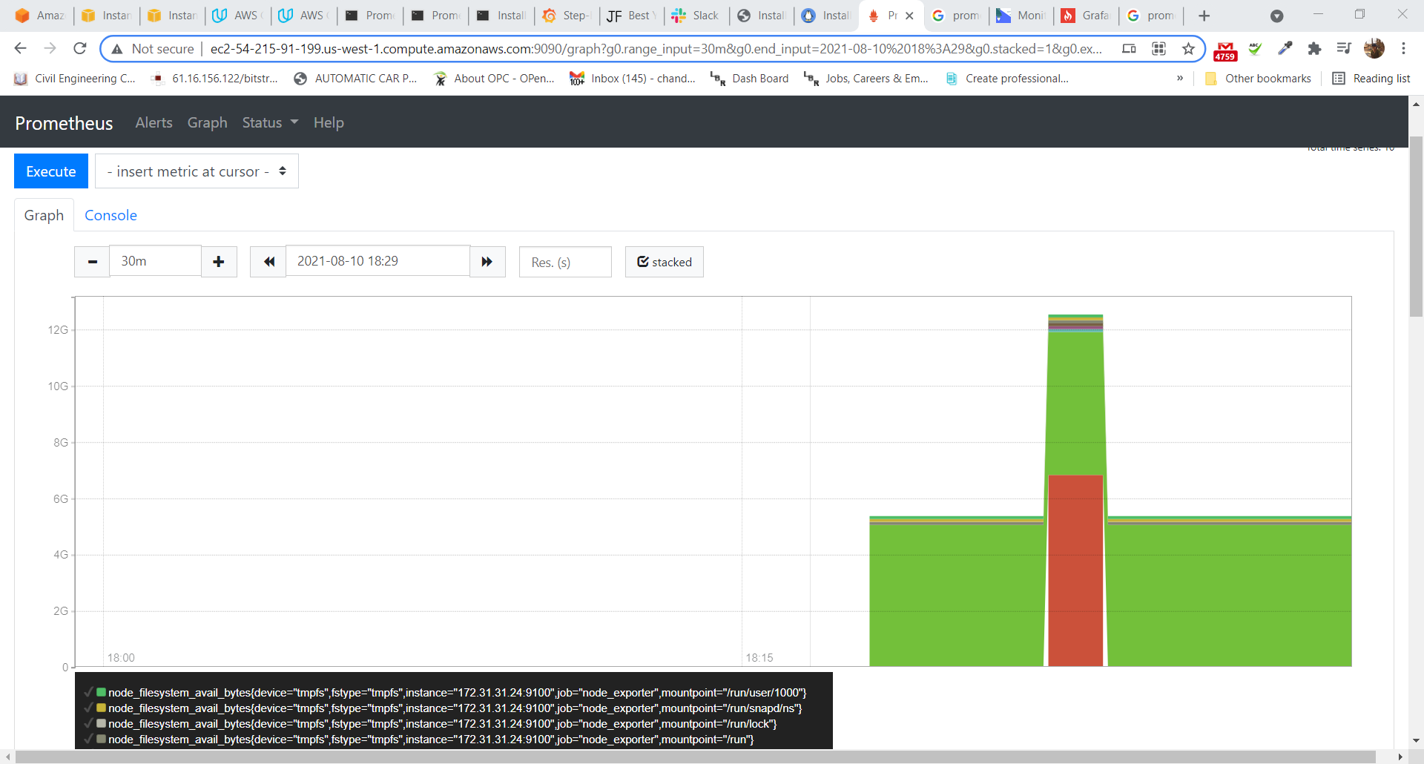

# SCREENSHOT-12 – Alerts in Slack , when instance is down

